FACULTY EVALUATION
Programme Name: Resource Mobilization Programme
Session: Introduction to Resource Mobilization
Faculty Name: Annette Murunga
No. of Respondents: 16
No. of Participants: 16
Evaluation Parameter | (%) Individual Score | (%) Programme Average
Punctuality | 92 | 96
Clarity of presentation | 88 | 94
Degree of preparation | 85 | 94
Course design & org | 87 | 91
Content & methodology | 87 | 93
Quality of discussions | 88 | 94
Relevance to work | 91 | 95
Average scores | 88 | 94

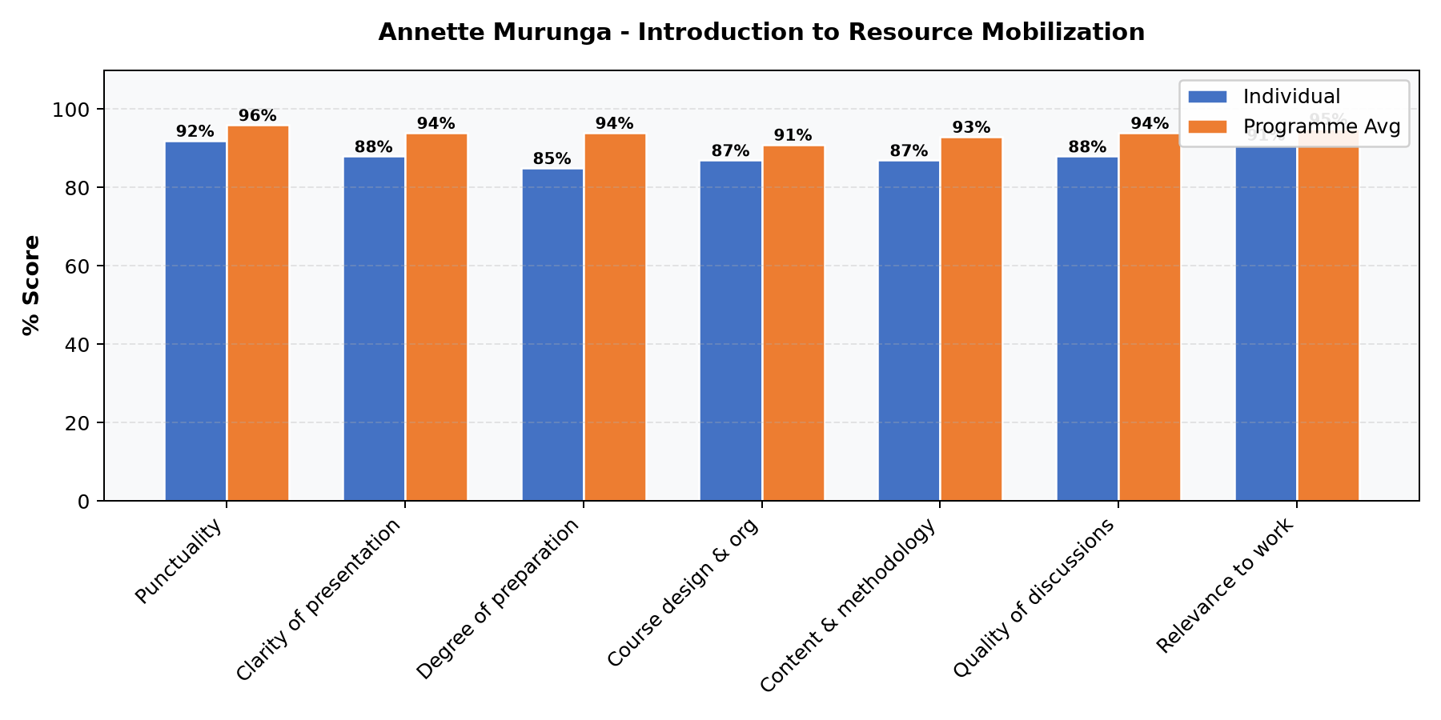

Comments & Feedback
- • Met my expectations
- • Ms Murunga set an excellent foundation to the course
- • The powerpoints could be improved in terns of font and color
SUBMITTED THROUGH:
NAME: ______________________ SIGN: ______________________ DATE: ______________________

